**Information Literacy UNIT:**

**Web Evaluation**

C:\Program Files\Microsoft Office\MEDIA\CAGCAT10\j0285750.wmfC:\Program Files\Microsoft Office\MEDIA\CAGCAT10\j0205582.wmf

**Directions**: View the **Web Evaluation** power point which is posted in Handouts in the Information Literacy Unit page link in your course on STInet. If necessary, Google for some of these answers. Complete the following questions:

1. Who were the first Internet users?
2. What are the main functions of the Web?  
     
   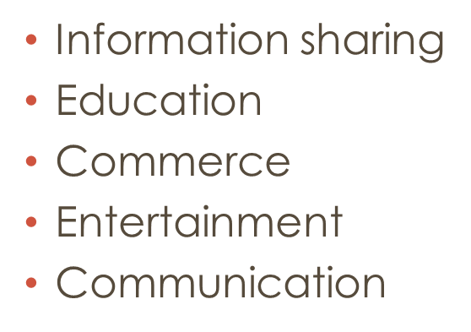
3. What is the average lifespan of a URL?  
     
   **The average lifespan of URL is 100 days.**
4. About how many new web pages go onto the Web every day?  
     
   **More than 7.5 million web pages go onto the Web every day.**
5. Are websites generally subject to a review/selection process?  
     
   **NO**
6. What are search engines?  
   **A program that searches for and identifies items in a database that correspond to keywords or characters specified by the user, used especially for finding particular sites on the World Wide Web.**
7. Which search engine is suggested as a reliable choice for you to use while searching?  
     
   **Google**
8. Why is Yahoo not a reliable search engine?   
     
   **It display some irrelevant results not the particular result.**
9. List four criteria for evaluating web pages.   
   **Origin, authority, purpose, and objectivity or bias.**